Growth Mindset –
a guide for parents

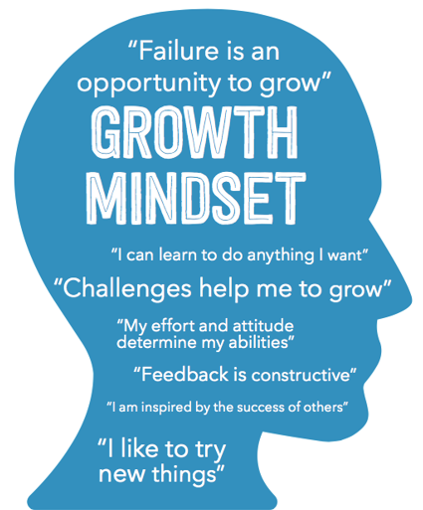


What is a growth mindset?
Has your child ever said to you ‘There’s no point, I’ll never be able to do it’ or avoided doing something because they’ve failed at it in the past? Feelings like this can be related to what children believe about what makes them ‘good’ at something – whether it’s school work, sport, or even their ability to manage their emotions and behaviour.
Some children will tend to give up on challenging tasks easily or avoid tasks they’ve failed at before. They tend to believe that being ‘good’ at a particular activity is a fixed state and is something they can’t control. In psychology, this way of thinking is called a ‘fixed mindset’.
Others might bounce back quickly from failure and be more likely to explore how they can get better at doing something. They tend to be children who believe that you can improve your abilities by practising, or by finding a different way to achieve your goal. This way of thinking is called a ‘growth mindset’ and developing it can help make children more resilient for life.
Children (and adults!) with a growth mindset believe that intelligence and abilities can be developed through effort, persistence, trying different strategies and learning from mistakes.
On the other hand, people with a fixed mindset believe that our intelligence and abilities are fixed traits; something that you are born with and that you can’t really do anything about.

How do the different Mindsets develop and why are they important?
Most babies are excited to learn. However, as soon as children are able to compare themselves to others, some will stop focusing on learning and will instead focus on performance; they want to look good in front of others and more importantly, they want to feel like they are the best.
According to someone with a fixed mindset, if you fail at something, make a mistake, or even have to put effort in, it must be because ‘you’re just not good enough’. Because of that belief, children begin to avoid challenges and choose activities that they find easy.
People with a fixed mindset feel as if they have no control over their abilities and are helpless in the face of difficulties and setbacks. They begin to feel disheartened if they find something difficult, which can lead to low self-esteem and a developing sense that there is ‘no point’ in trying.
Over time, children who feel like this may decrease their efforts and sometimes even engage in disruptive behaviours (anything that will detract from the fact that they are struggling).
Children (and adults!) with a growth mindset think very differently. They believe that they can get better at something by practising, so when they’re faced with a challenge, they become more and more determined to succeed, wanting to persevere and overcome knockbacks. They tend to feel as if they’re in control and are not threatened by hard work or failure.
Although no one likes failing, children with a growth mindset do not let failure define them; instead, they use setbacks to motivate them. Children encouraged to adopt a growth mindset enjoy challenges and the sense of achievement they get when they succeed.
Researchers have found that building a growth mindset helps children at school; making them more motivated, more engaged in the classroom and likely to receive higher marks and greater rewards from their work.

How is school helping my child to develop a growth mindset?
In school we are introducing a range of strategies and practices that will support pupils to develop a growth mindset. Staff have been working hard to develop suitable resources and systems that we hope will reap dividends on the classroom.

Infant pupils will focus upon developing the characteristics of learning ‘superheroes’; each character has a particular learning superpower and pupils are encouraged to demonstrate these characteristics in their own learning. There are also some ‘super villains’ (who have fixed mindset traits) that the children need to try to defeat through their positive learning behaviour.
The approach is based upon rewarding the pupils for their efforts and when they demonstrate growth mindset within their learning they collect the relevant superhero reward sticker.
 |  | 

Juniors: Having a fixed mindset is prevalent amongst pupils of all abilities and often most impacts upon pupils who consider themselves to be clever or high achievers (the sense of always wanting to be correct leads children to take less chances and only try things they know they can already do). We feel that all our pupils can improve their learning mindset.
We want our Junior pupils to develop their resilience and independence when working upon independent tasks. Too often pupils tend to ‘give-up’ without having really tried to complete a task as they consider it to be ‘too difficult’ or they ‘don’t get it’. In order to improve how well they persevere with their work we have developed a simple set of rules that children will be expected to follow (Percy Verance’s 5 finger rule).

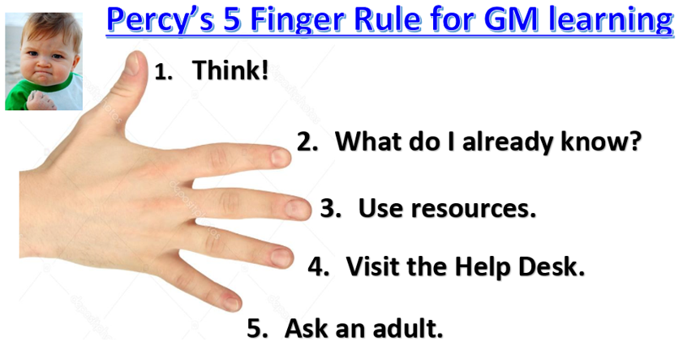 |   The talisman for the Junior growth mindset focus is Percy Verance.

Awards
In the classroom, children are rewarded for showing a growth mindset attitude to their learning (through specific stickers / merit points) and each week two children per year group receive a class award and are celebrated in Awards Assembly.

How can I help my child to develop a Growth Mindset?
The exciting thing about the growth mindset approach is that it is not just about ability. It focuses on what people believe about ability – and there are lots of ways that we can help our children to develop a growth mindset.
Research has shown that Mindsets can be changed relatively quickly and there are plenty of things that parents and families can do to help. Below are a few tips and ideas that can help promote a growth mindset in children.

Set high expectations for your child:
It is commonly believed that lowering our expectations promotes self-esteem in children (e.g. “never mind, let’s try an easier one”), but this is not the case. Having high expectations works like a self-fulfilling prophecy. It shows that you believe they can do it, which in turn has a positive impact on their own beliefs, behaviour and outcomes.

Encourage children to be resilient and not give up, even when they find something difficult or frustrating:
We now know that the brain adapts to new information and practise by creating new connections, so help your child to believe that challenge is a positive thing because it means they are growing their brains! This can help them to be comfortable with the times that they struggle and means that they see this as a sign of learning.

Celebrate mistakes!
The fear of making mistakes and associated shame can stop children from giving something a go in the first place. We all make mistakes, so try to embrace these mistakes and use them as learning opportunities, rather than feeling embarrassed about them. If we are not making mistakes then we are not stretching ourselves.

Use inspirational role models:
Think about your child’s favourite athlete, musician or teacher and talk about their journey to success. We call this unravelling the talent myth. If someone has done well we have a tendency to think they were born that way. We need to show our children that this is not the case. Rather than focusing on somebody’s ‘natural talents’, focus on their early efforts, strong work ethic, and the mistakes and learning that led them to where they are now.

How can the way I praise my child help develop a Growth Mindset?
It’s natural to want to praise children when they do something well, but we need to do this carefully. Research suggests that the type of praise that we use can have a big impact. It's all a matter of context in fact and even positive praise can encourage a fixed mindset.

Praising our children by saying things like “you’re a natural!” or “you seem to be able to turn your hand to anything!” without clarity of the process by which they got to that point can lead to the belief that being good at something is out of their control. In other words, understanding how they got there is the key.

Instead the grown-ups around the child can focus praise on the effort they’ve made to get to that point of triumph, the strategy they used or the outcome itself, saying things like “you’ve worked so hard on this, well done!” or “you get better every time because of all the practise you’ve been doing” or “you have found a great way to do that, it worked out really well”.

This kind of feedback helps to develop children’s resilience to failure as it teaches them what to do when they are challenged or fail – try again, try harder or try a different way, all things that are within their own control.
This type of praise is sometimes called ‘process praise’ and children are more motivated when their parents used more of this kind of praise.

