St. Mary’s Catholic Primary
Calculations Policy

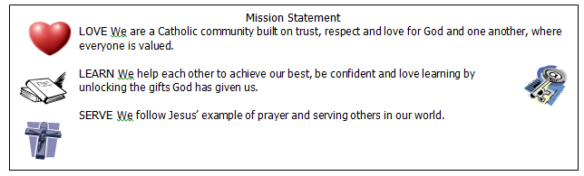

Addition
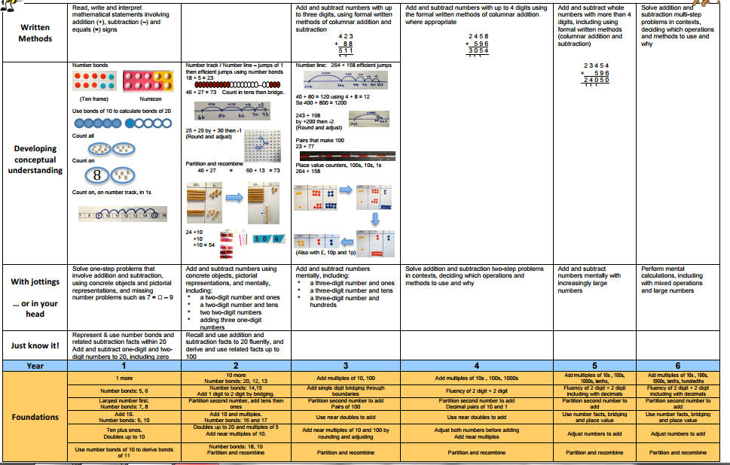
Subtraction
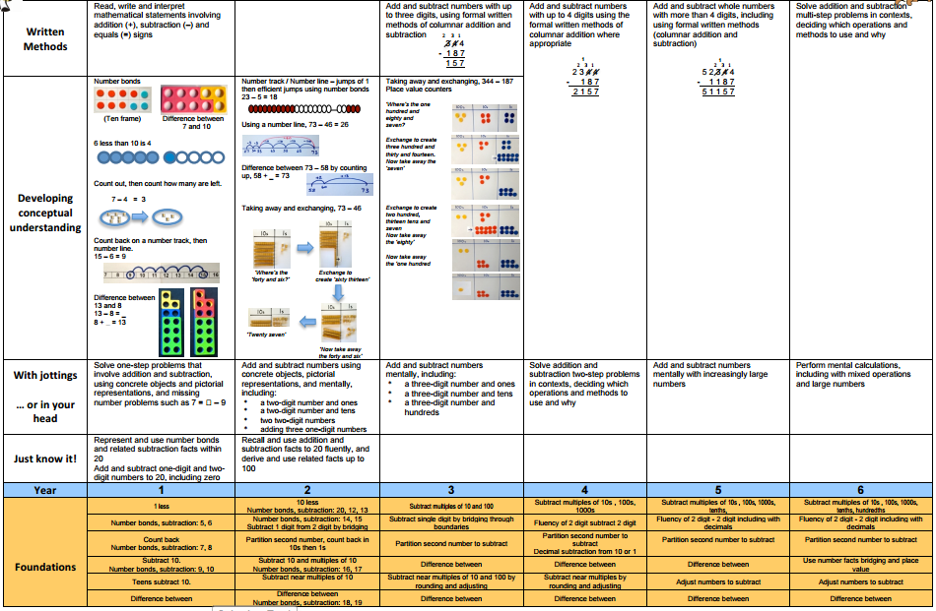
Multiplication
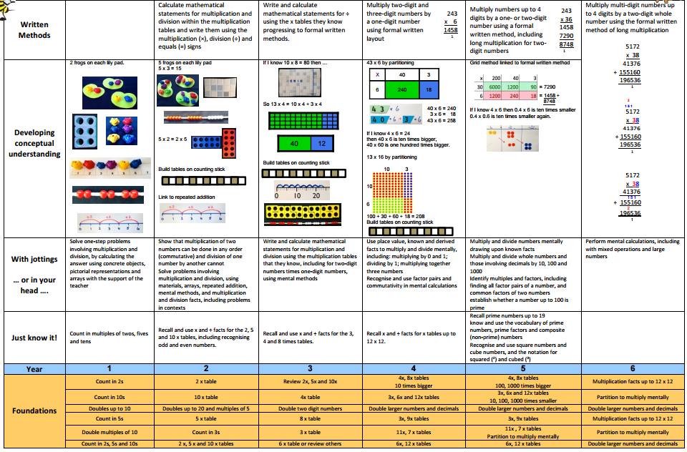
Division
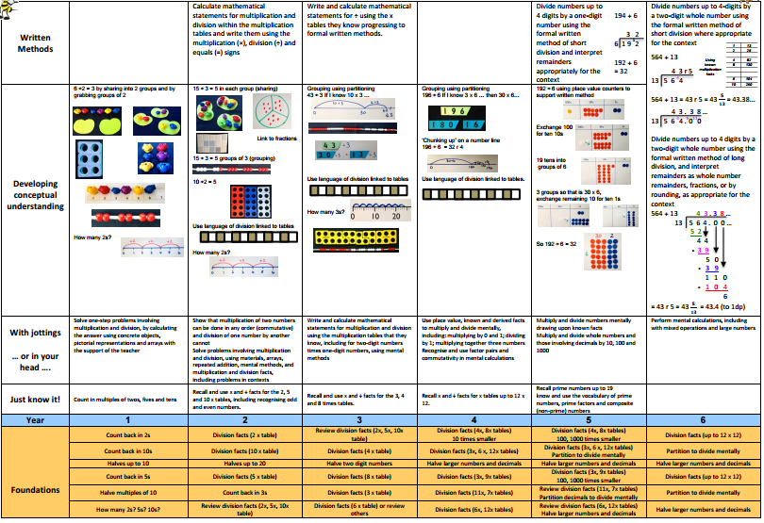
Bar Models
The bar model method is a strategy used by children to visualise mathematical concepts and solve problems. The method is a way to represent a situation in a word problem, usually using rectangles or ‘bars’.
See below for some images of bar models.
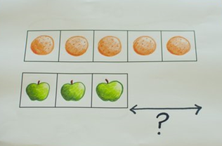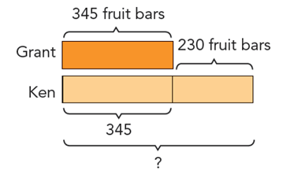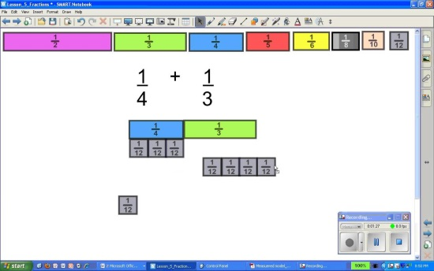
A Fullerton February 2017

